 | YEAR 12 MATHEMATICS SPECIALIST  SEMESTER TWO 2016  TEST 3: Derivatives and Integrals

Name: _______________________

Monday 15th August Time: 45 minutes Mark /40
Section 1 – Calculator free 20 marks

[4 marks]
A curve is defined by the equation
Use implicit differentiation to determine the equation of the normal drawn at the point.

[3 marks]
Determine the area enclosed by the curves and , as shown.
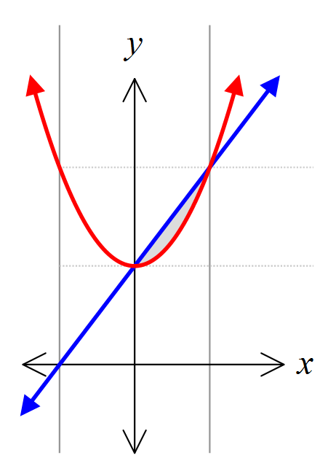

[13 marks – 4, 1, 4 and 4]
Determine each of the integrals given
- by using a suitable substitution

- in the form

Section 2 – Calculator assumed 20 marks

[3 marks]
Determine the volume generated when the region enclosed by the curves and , as shown, is rotated around the x-axis.

[5 marks – 2, 2 and 1]
Fluid flow through a narrow pipe has been modelled by the equation where F is the flow, k a constant and r the radius.
- How will the rate of flow change if the radius is increased by 44%?

- Use the incremental technique to estimate the change of radius that produces a 10% decrease in flow.

- Is the incremental technique appropriate in (a)? Explain.

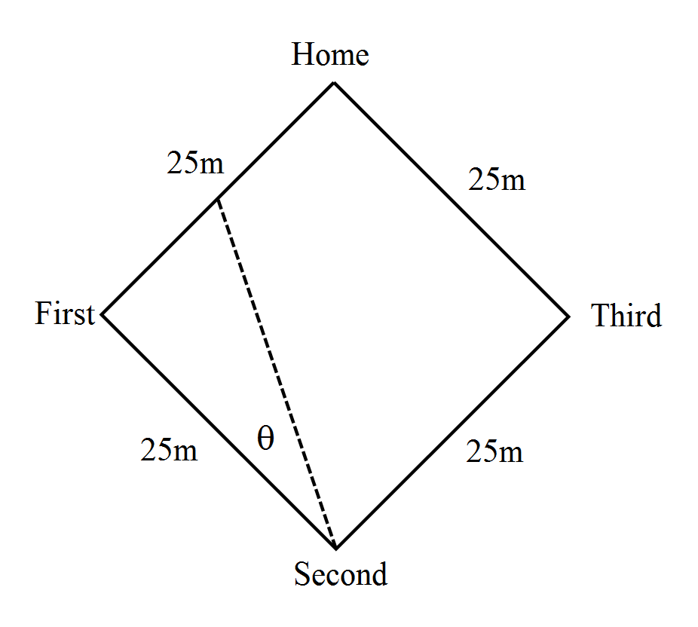 [7 marks – 4 and 3]

A baseball diamond consists of a 25 metre square.

A batter goes from the home plate and runs directly towards first base at 8 metres per second.

How fast is his distance from second base changing when he is half-way to first base?

How is angle θ changing at the same instant?

[5 marks]

Calculate the exact volume generated when the region contained between and for is rotated about the y-axis.

